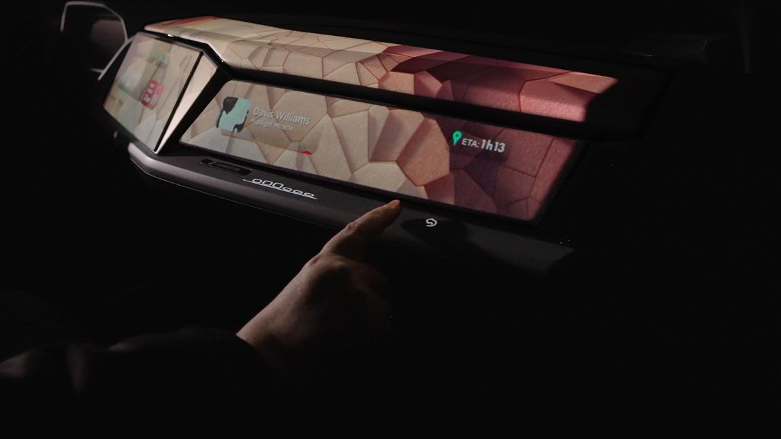

At CES 2024, Valeo and Sennheiser present ImagIn: an immersive sound and light experience in your car

Brussels, October 2nd – Valeo and Sennheiser have combined their technologies to design a unique immersive sound and light experience and will present the ImagIn demo car for the first time at CES 2024 in Las Vegas.

Expectations for personalized experiences continue to grow, especially as vehicles become more autonomous and passengers have more time to enjoy a new kind of interior experience. Valeo and Sennheiser Mobility have worked together to develop a unique multisensorial exploration where light combines with immersive sound, offering a new level of immersion. The heart of our common vision is to change the way of perceiving car interiors, transforming onboard spaces into informative, entertaining, and immersive zones. With ImagIn, the car becomes a cocoon of well-being.

The partnership between Valeo and Sennheiser embodies a common commitment to excellence and a passion for pushing the boundaries of innovation.

Valeo has developed improved technologies for daytime projection to deliver an onboard polysensorial and immersive experience. Moving beyond a driver-centric approach, all passengers will experience unique style and functionalities, thanks to an interior projection on surfaces and sound management. The Valeo interior lighting system is composed of projection modules, a smart adaptable user-interface based on gesture detection and a software dedicated to projection and content management. This innovative system will extend the useful surfaces and make them accessible for all passengers thanks to a human-machine interface (HMI) at the front and the back of the vehicle. Beyond its practical utility, it transforms the vehicle design without impacting the hardware, combining visual projected content with smart surfaces and sound for an immersive and intuitive experience. ImagIn covers 5 patents for this innovation.

Sennheiser’s advanced audio system creates the illusion of a sound stage around each passenger, transforming every ride into a breathtaking soundscape. It transforms the entire cabin into a vibrant multi-dimensional soundscape. The Immersive sound zone algorithm for headrest audio in all seats, along with animated visuals, increases the acoustic separation between each seat row, allowing passengers to enjoy tailor-made travel experiences.

